Linux-Exercise 7-File permissions
- Create a new file first.txt and a new directory second to your home directory. What are the permissions for newly created file and directory?
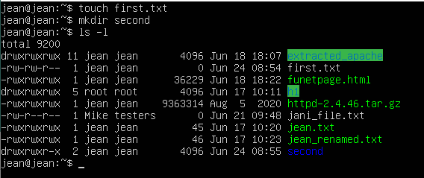
- Change file (first.txt) permissions using numerical format in the following way: owner → all permissions, group → read and write permissions and other → no permissions. Return original permissions for the file using symbolic format.
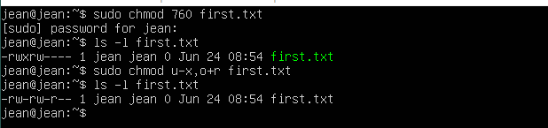
- Change root or other user for the owner for the directory (second).
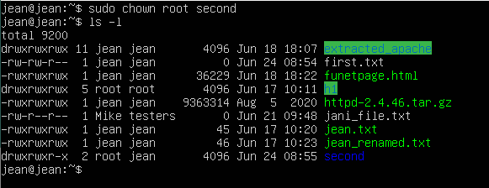

- Change directory permissions in a way that only owner has permissions for the directory.
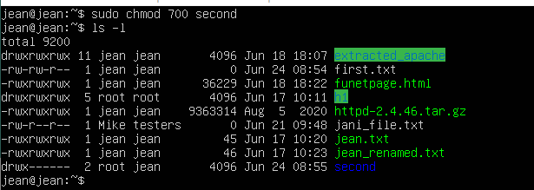
- Create a new file and set root or other user as a file owner.
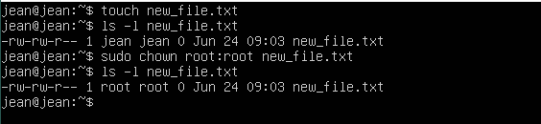

- Create two files: hard_link.txt and soft_link.txt. Create hard and soft link for these files according to file names. Check the results with ls -l command. What does the output of the command tell about the links and how do links differ? Remove the files you created and recheck the results with ls -l command. What differences do you notice?
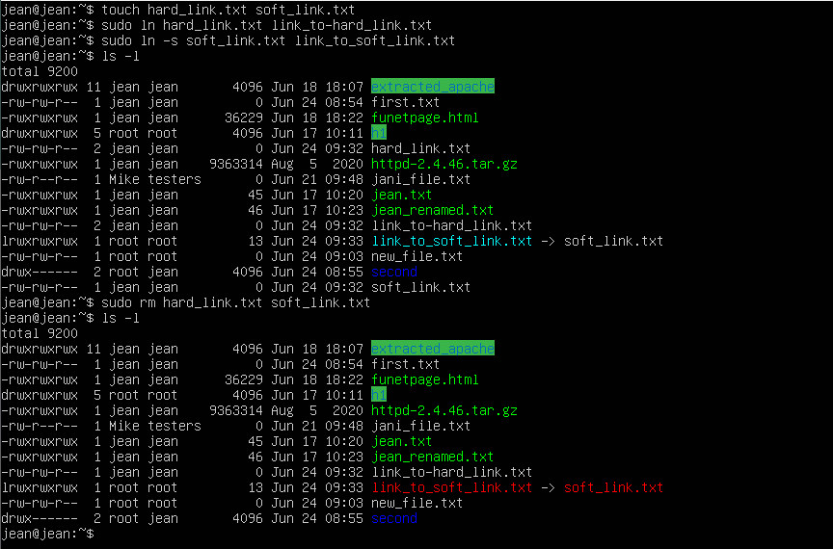
- Use find command to list /etc directory contents including only files with .conf extension and starting with letter l (small l, not capital I). Do not include files from subdirectories!
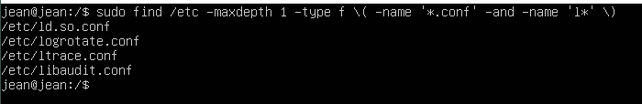

- Below is a presentation of a directory structure where temperature data from sensors s1, s2 and s3 has been saved for log files under sensor specific directories. Create this directory structure with files. Important: Check the location of this directory structure within the Linux filesystem!
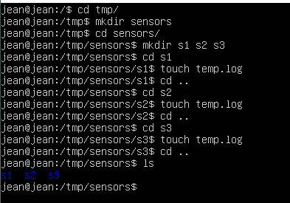
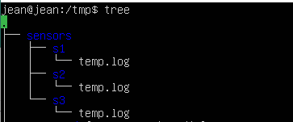
- Users user (regular user) and root have been marked for the directory presentation below. Create the following permissions: user can only access the first sensor's temp.log file and root has access to the whole directory structure. User should have adequate permissions for reading and editing the temp.log file.
